1. **Spring Configuration with Java Code 🡺 Java Config,** Instead of xml configuration, use java code
2. **3ways to Configure:** Full XML config, XML component scan, Java Configuration Class.
3. **Below 🡺 Write java code to configure spring container. @Configuration, @Bean and injecting dependencies.**
4. 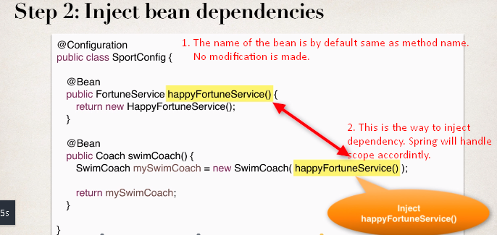  
   Below: Reading java configuration code.  
   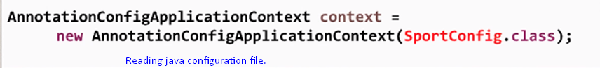
5. Method annotated with @Bean
   1. By default singletone, b. Their call is intercepted by spring (Scope irrelevant). c. Default name is same as method name without any modification.
6. **Reading from property file @PropertySource, @Value**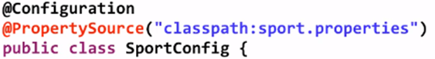 ****.
7. **Spring** **4.2 or lower**: When using Java Code to configure spring container, and to read from property file using **@PropertySource**(“**classpath**:sport.properties”),   
   it will not work as you along need to configure 